

**The University of Azad Jammu & Kashmir, Muzaffarabad**

**Group No:** 02 **Project Report**

**Group Members**

Jawahir Ali (2024-SE-34)

Kamal Ali Akmal (2024-SE-38)

Muqaddas Kiani (2024-SE-23)

**Course**   Object Oriented Programming (OOP)

**Submitted To**   Engr. Awais Rathore

**Date**   26 September 2025

**Session**  2024-2028

**Department**  Software Engineering

**FARMING MANAGEMENT SYSTEM**

**📋 Table of Contents**

1. ***Project Overview***
2. ***Main Objectives***
3. ***OOP Concepts Used***
4. ***Libraries Used***
5. ***System Architecture***
6. ***Functionality***
7. ***Code Structure***
8. ***Features***
9. ***Technical Implementation***
10. ***Conclusion***

**1. Project Overview**

The **Farming Management System** is a comprehensive C++ application designed to modernize agricultural operations through digital management. This system provides farmers with a centralized platform to manage all aspects of their farming business, from crop planning to equipment maintenance and inventory management.

**Main Aim of the Project**

The primary aim is to develop an **integrated digital solution** that helps farmers efficiently manage their agricultural operations, reduce manual record-keeping, and make data-driven decisions for improved productivity and profitability.

**2. Main Objectives**

* ✅ **Digital Transformation**: Replace traditional paper-based farming records with digital management
* ✅ **Centralized Management**: Provide a single platform for all farming operations
* ✅ **Data Persistence**: Ensure all farm data is securely stored and easily accessible
* ✅ **User-Friendly Interface**: Create an intuitive system accessible to farmers with basic computer skills
* ✅ **Decision Support**: Provide intelligent insights like weather-based farming recommendations
* ✅ **Security**: Implement secure user authentication to protect farm data

**3. OOP Concepts Used**

Following OOP concepts used in project:

**3.1 Encapsulation**

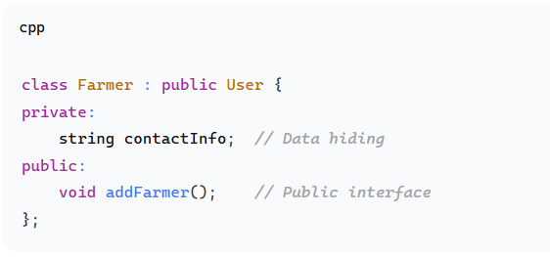

* **Data Hiding**: All class attributes are private
* **Access Control**: Public methods provide controlled access to data

**3.2 Inheritance**

* **Code Reusability**: Farmer class inherits from User class
* **Hierarchical Structure**: Natural parent-child relationships

**3.3 Polymorphism**

* **Method Overriding**: Derived classes provide specific implementations
* **Virtual Functions**: Enable dynamic binding

**3.4 Abstraction**

* **Complexity Hiding**: Users interact with simple interfaces
* **Implementation Separation**: Internal details are abstracted

**3.5 Class and Objects**

* **Real-world Modeling**: Classes represent real entities
* **Object Interaction**: Objects communicate through methods

**3.6 File Handling**

* **Data Persistence**: Store data in text files
* **CRUD Operations**: Create, Read, Update data files

**4. Libraries Used**

Following Libraries used in project:

**4.1 Standard Template Library (STL)**

**4.2 Custom Header Files**

**5. System Architecture**

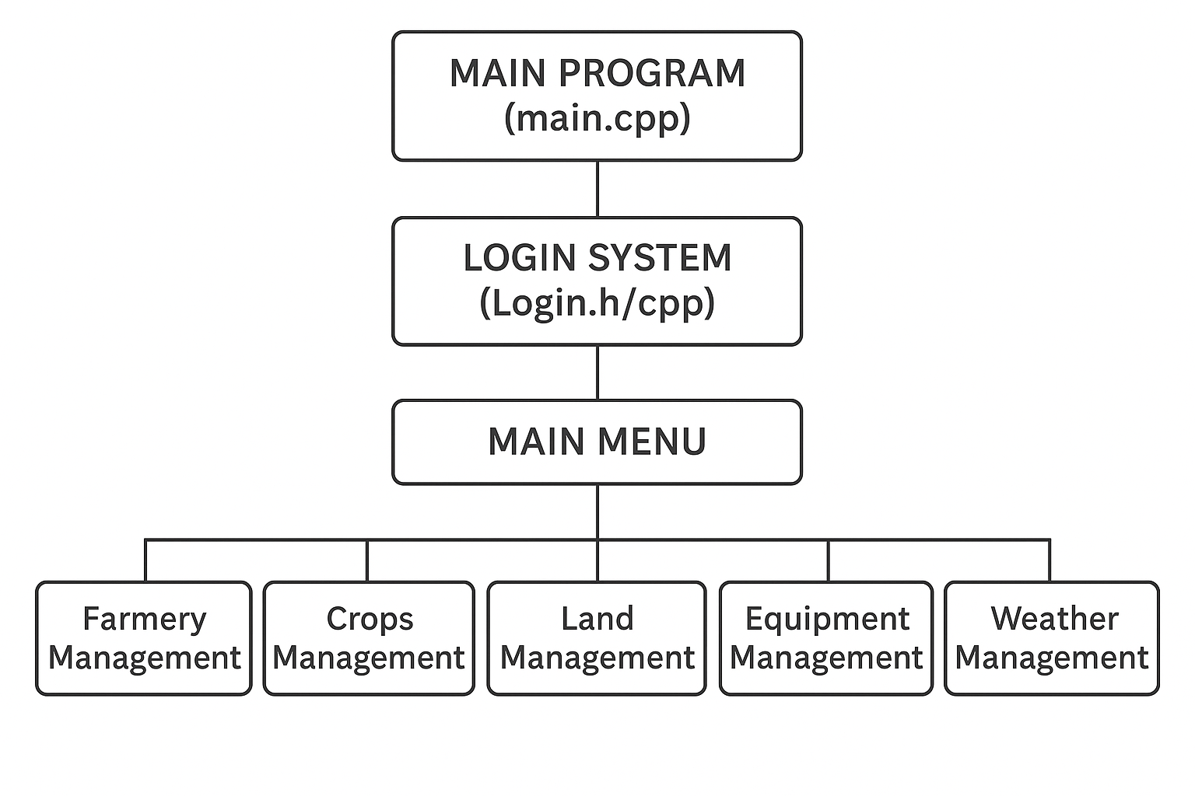

**6. Functionality**

System will provide following Functionality:

**6.1 User Authentication**

* **User Registration**: New users can create accounts
* **Secure Login**: Password-protected access
* **Session Management**: Maintains login state throughout usage

**6.2 Farmer Management**

* **Add Farmers**: Register new farmers with complete details
* **View Farmers**: Display all registered farmers in tabular format
* **Contact Management**: Store and manage farmer contact information

**6.3 Land Plot Management**

* **Plot Registration**: Add new land plots with size and location
* **Plot Status**: View all land plots and their assigned crops
* **Crop Assignment**: Assign specific crops to land plots

**6.4 Crop Management**

* **Crop Planning**: Add crops with growth stages and harvest dates
* **Growth Tracking**: Monitor crop development stages
* **Harvest Scheduling**: Plan and track harvest timelines

**6.5 Equipment Management**

* **Equipment Registry**: Maintain inventory of farming equipment
* **Status Tracking**: Monitor equipment condition (Operational/Maintenance)
* **Plot Assignment**: Assign equipment to specific land plots

**6.6 Inventory Management**

* **Stock Management**: Track farming supplies and quantities
* **Low Stock Alerts**: Color-coded warnings for low inventory
* **Item Categorization**: Organize items by type and purpose

**6.7 Weather Intelligence**

* **Weather Monitoring**: Display current temperature and rainfall
* **Farming Advice**: Provide intelligent recommendations based on conditions
* **Condition Alerts**: Warn about unfavorable farming conditions

**6.8 Data Validation**

* **Input Validation**: Ensure all user inputs are correct and formatted
* **Error Handling**: Provide clear error messages with guidance
* **Data Integrity**: Prevent invalid data from entering the system

**7. Code Structure**

Code Structure is as follows:

**7.1 Header Files (.h)**

* **User.h**: Base user class definition
* **Farmer.h**: Farmer class inheriting from User
* **Crop.h**: Crop management class
* **LandPlot.h**: Land plot management class
* **Equipment.h**: Equipment tracking class
* **Inventory.h**: Inventory management class
* **Weather.h**: Weather module class
* **Login.h**: Authentication system class
* **Validation.h**: Input validation functions

**7.2 Implementation Files (.cpp)**

* **Main.cpp**: Program entry point and menu system
* **User.cpp**: User class implementation
* **Farmer.cpp**: Farmer class implementation
* **Crop.cpp**: Crop management implementation
* **LandPlot.cpp**: Land plot operations
* **Equipment.cpp**: Equipment management
* **Inventory.cpp**: Inventory operations
* **Weather.cpp**: Weather functionality
* **Login.cpp**: Authentication system
* **Validation.cpp**: Input validation implementation

**7.3 Data Files (.txt)**

* **users.txt**: User credentials storage
* **farmers.txt**: Farmer records
* **crops.txt**: Crop information
* **landplots.txt**: Land plot data
* **equipment.txt**: Equipment records
* **inventory.txt**: Inventory items

**8. Features**

The features used in the system are as:

**8.1 Security Features**

* 🔐 **Password Protection**: Secure user authentication
* 👤 **User Sessions**: Maintain login state securely
* 📊 **Access Control**: Role-based system accessibility

**8.2 Data Management**

* 💾 **Persistent Storage**: All data saved to files
* 📈 **Data Integrity**: Validation ensures clean data
* 🔄 **CRUD Operations**: Complete data management cycle

**8.3 User Experience**

* 🎨 **Color-Coded Interface**: Visual feedback system
* 📱 **Intuitive Navigation**: Easy-to-use menu system
* ⚡ **Real-time Validation**: Immediate input feedback

**8.4 Agricultural Intelligence**

* 🌤️ **Weather Integration**: Smart farming recommendations
* 📅 **Harvest Planning**: Automated scheduling assistance
* ⚠️ **Alert System**: Proactive condition warnings

**9. Technical Implementation**

**9.1 File Handling Mechanism**

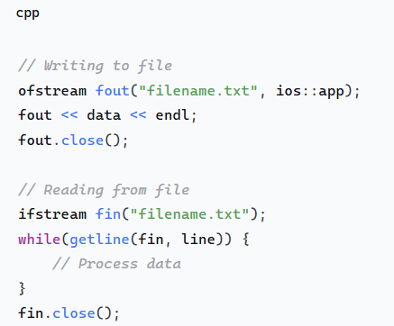

**9.2 Input Validation System**

**9.3 Menu Navigation**

**10. Conclusion**

**10.1 Achievements**

✅ **Successfully implemented** all core OOP concepts in a practical application  
✅ **Created a comprehensive** farming management solution addressing real-world needs  
✅ **Developed a user-friendly** interface suitable for agricultural professionals  
✅ **Implemented robust** data validation and error handling mechanisms  
✅ **Achieved project objectives** of digital transformation in agriculture

**10.2 Learning Outcomes**

* **Enhanced understanding** of Object-Oriented Programming principles
* **Improved skills** in C++ programming and file handling
* **Gained experience** in project planning and team collaboration
* **Developed expertise** in user interface design and user experience
* **Learned practical** software development methodologies